NAAN MUTHALVAN

Unveiling Market Insights : Analysing Spending Behaviour And Identifying

**TEAM LEADER**

ANANTH.G

**TEAM MEMBERS**

AJITH KUMAR.V

AKASH.M

AJI.S

Unveiling Market Insights

Analysing Spending Behaviour And Identifying

# Introduction

Unveiling Market Insights: Analysing Spending Behaviour And Identifying Opportunities For Growth

# 1.1.Overview:

Unveiling Market Insights: Analysing Spending Behaviour and Identifying Opportunities for Growth. Creating Dashboard, Story using Tableau and analyzing Spending Behaviour and Identifying Opportunities for Growth.

# 1.2.Purpose:

A market analysis provides information about industries, customers, competitors, and other market variables. You can also determine the relationship between supply and demand for a specific product or service. Based on these insights, you can make more informed decisions about possible marketing strategies..

# 2. Problemstatement & designthinking

2.1.Empathy map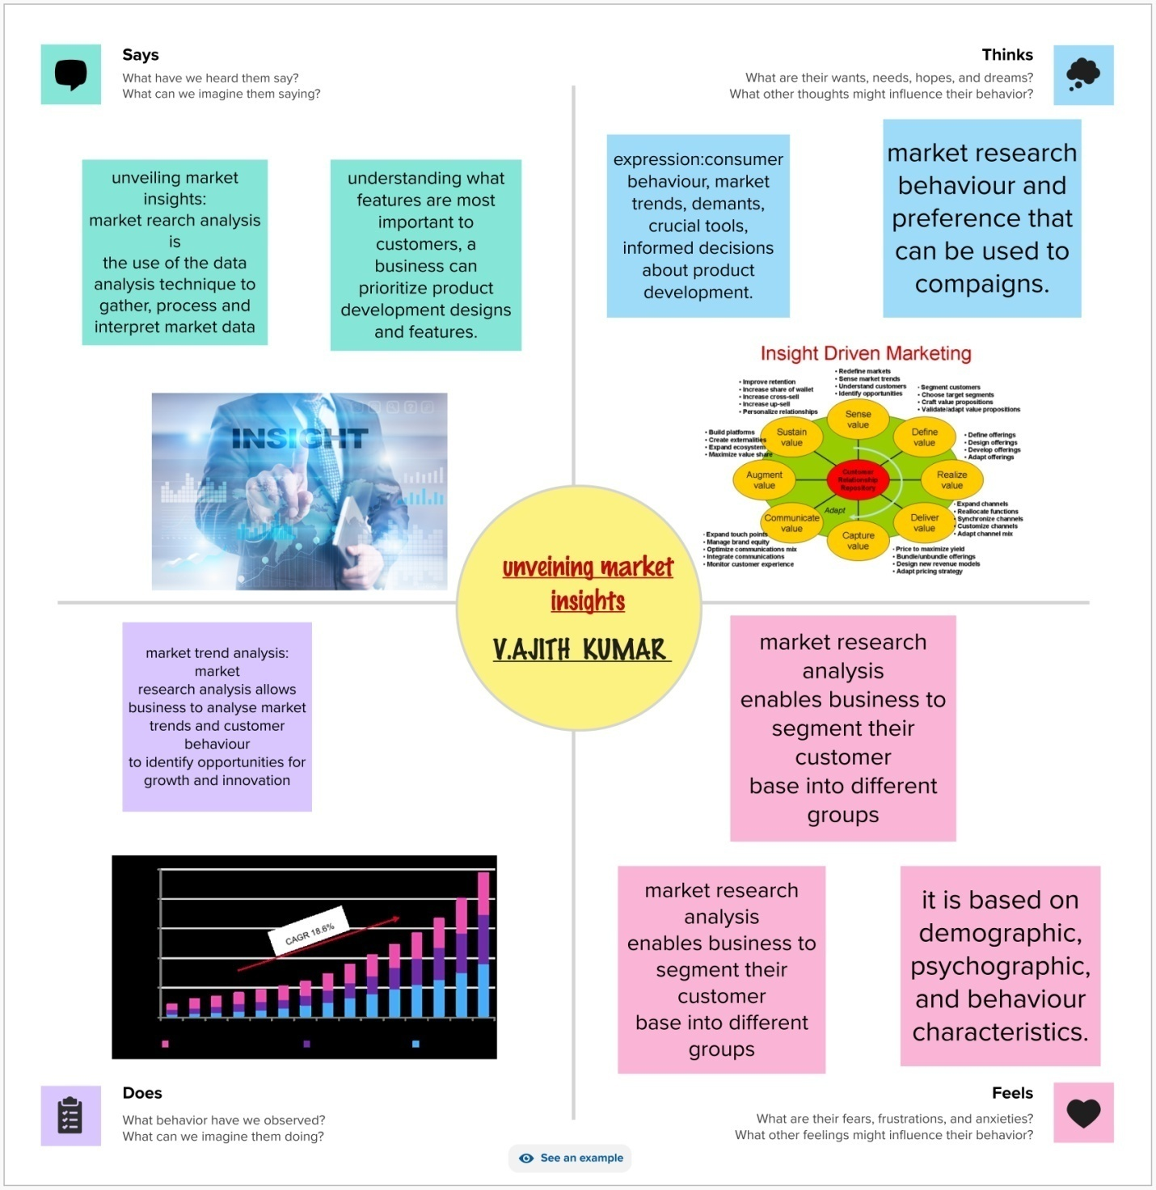

# 2.2. brinstorming map

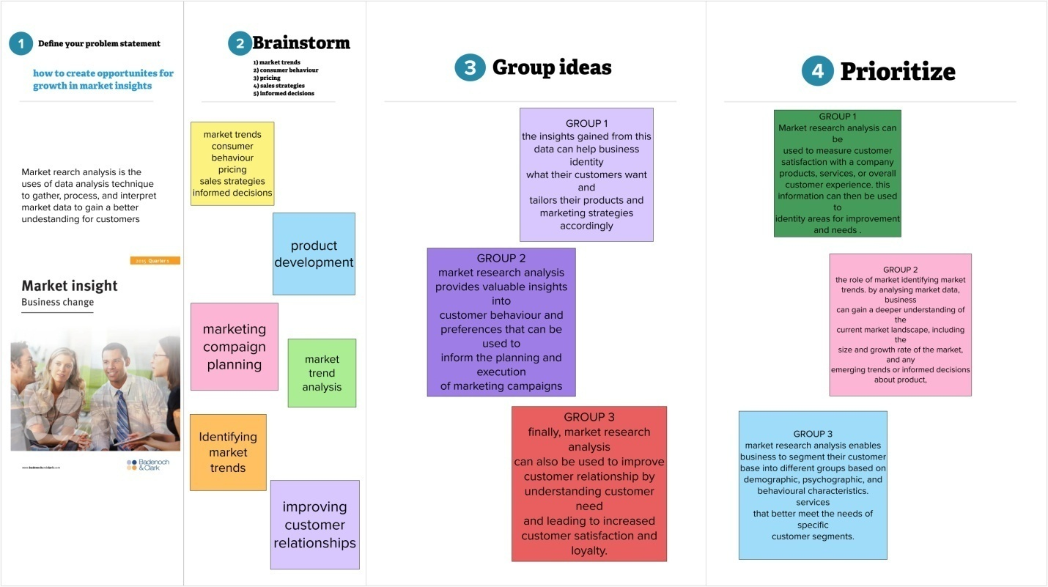

# 3. Resultsheet 1.pngsheet 2.pngsheet 3.pngsheet 4.pngsheet 5.pngsheet 6.pngsheet 7.pngsheet 8.pngsheet 9.pngSTORY.png

# STORY.png

# 4. Advantages & disadvantages

## Advantages:

Notable benefits of a market economy are increased efficiency, production, and innovation.

## Disadvantages

Another drawback of observational research is the risk of bias and subjectivity in the data collection and analysis process. Bias can occur when the researcher or the observer has preconceived notions, expectations, or preferences that influence what they observe, how they interpret it, or how they report it

# 5. Application

## Skills you will develop

* Tableau

* Data Literacy

* Data Analysis

* Data Preparation

* Business Intelligence

* Data Visualization

# 6. Conclusion

Conclusion. In a nutshell, consumer behaviour plays an important role for sales folks or marketers. As products are made to cater to consumer's needs and demands, the products should be carefully marketed for the successful achievements of organizational goals.

# 8. Futures cope

1. Barriers toentry and expansion

2. Network effects

3. Vertical integration

4. Suppliers' commercial practices

5. Behaviour of data users

6.Incentives for innovation